Finding Image Boundary Using Convolution Kernel
Experiment No: 28
Aim
To find the boundary of an image using a convolution kernel in Python with the OpenCV library.
Tools Required
- Python 3.x
- OpenCV (cv2)
- NumPy
- VS Code / PyCharm / Jupyter Notebook
- Input image (image.jpg)
Procedure
- Install OpenCV and NumPy:
Bash
pip install opencv-python numpy
- Read the input image using OpenCV.
- Convert the image into grayscale.
- Define a convolution kernel for boundary detection.
- Apply the kernel using cv2.filter2D().
- Convert the resulting image into a suitable display format.
- Display the original image and detected boundary.
- Save the boundary image.
Convolution Kernel
A simple 3 × 3 boundary detection kernel can be used:
This kernel highlights areas where there is a significant change in intensity, which corresponds to image boundaries/edges.

Code
import cv2
import numpy as np

# Read the image
image = cv2.imread("image.jpg")

# Check if image is loaded
if image is None:
print("Error: Image not found!")
exit()

# Convert image to grayscale
gray = cv2.cvtColor(image, cv2.COLOR_BGR2GRAY)

# Define boundary detection convolution kernel
kernel = np.array([
[-1, -1, -1],
[-1, 8, -1],
[-1, -1, -1]
], dtype=np.float32)

# Apply convolution
boundary = cv2.filter2D(gray, cv2.CV_32F, kernel)

# Convert result to displayable image
boundary = cv2.convertScaleAbs(boundary)

# Display images
cv2.imshow("Original Image", gray)
cv2.imshow("Image Boundary", boundary)

# Save boundary image
cv2.imwrite("boundary_image.jpg", boundary)

cv2.waitKey(0)
cv2.destroyAllWindows()
Output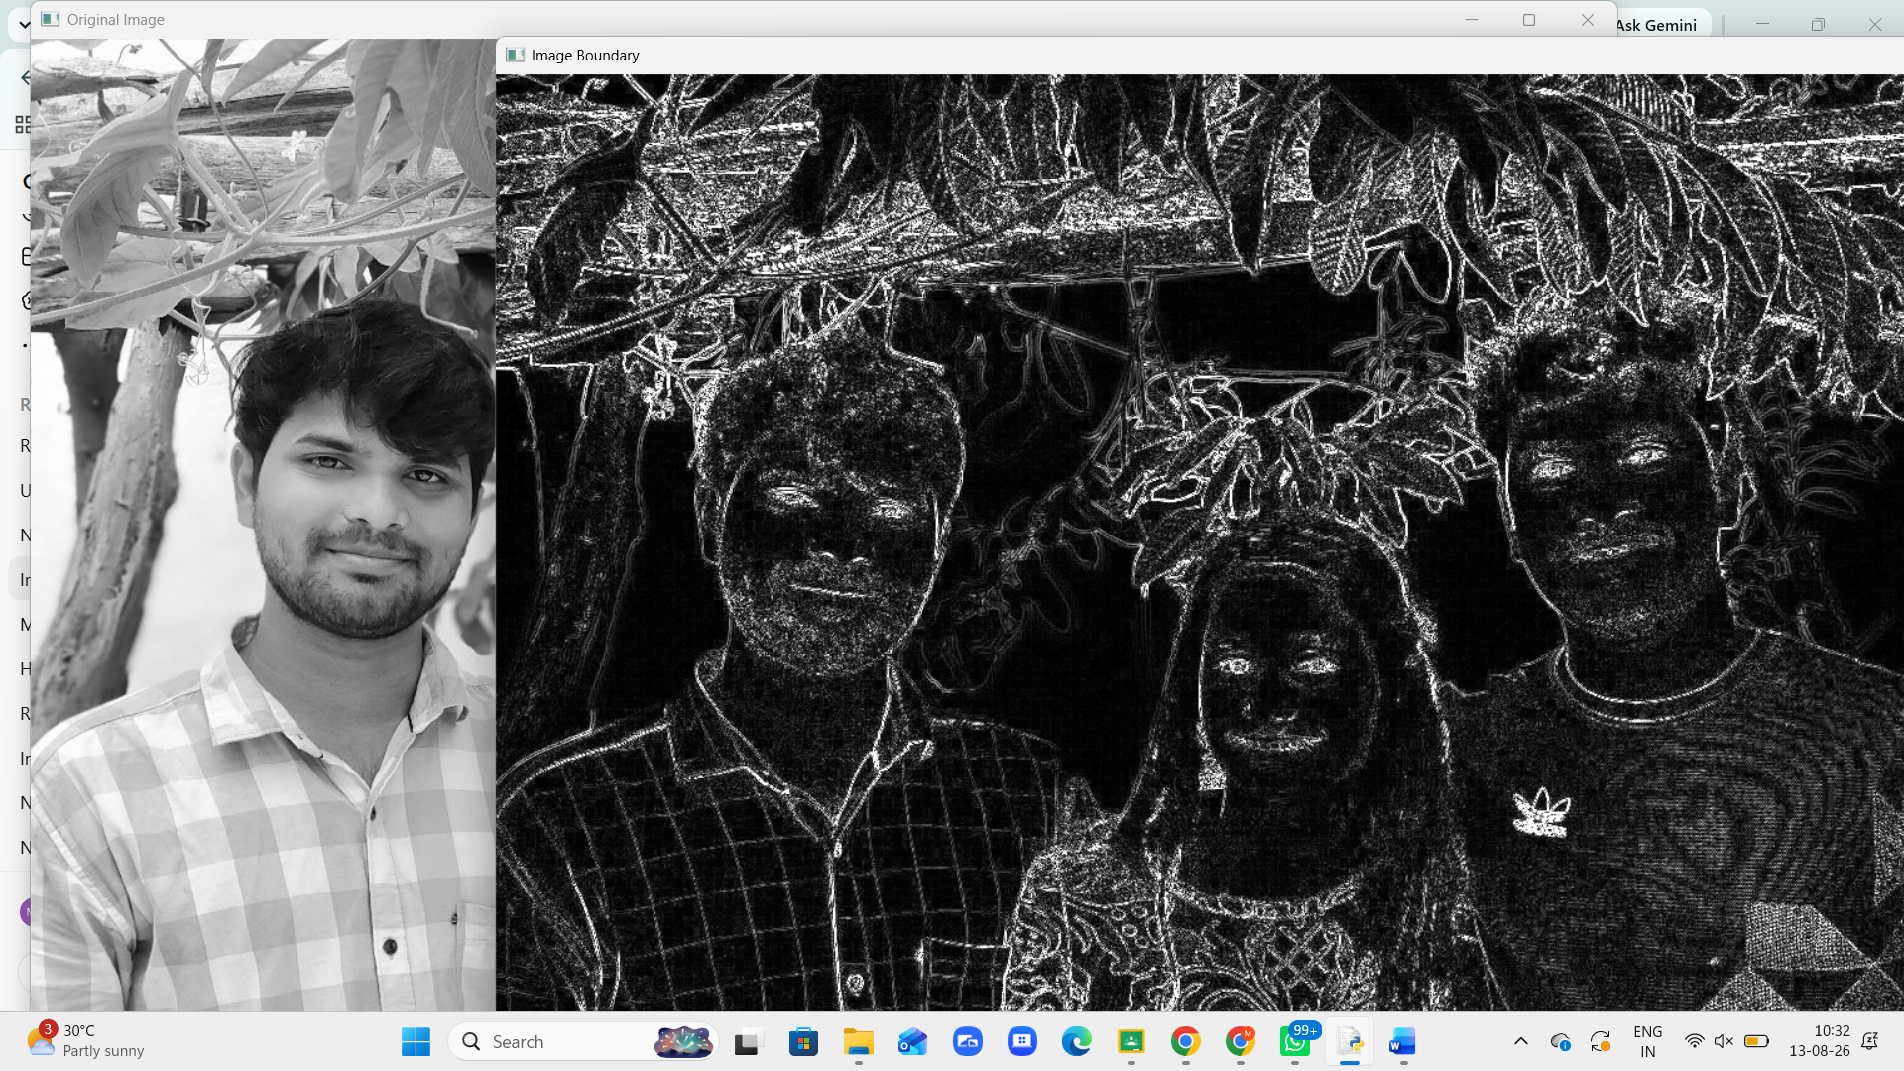
Result
The boundaries of the image were successfully detected using a 3 × 3 convolution kernel. The kernel highlighted the regions having rapid changes in intensity, producing the boundary/edge image successfully.

